Week 2 – BookFlow Database Management System
Step 1: Create Database
CREATE DATABASE bookflow_db;
USE bookflow_db;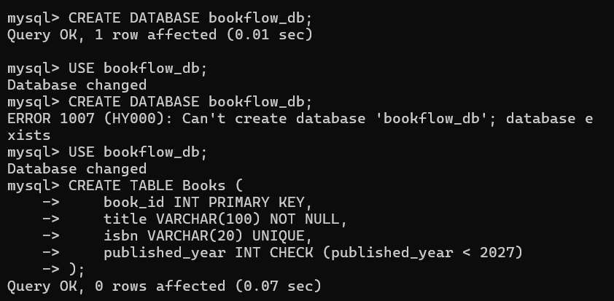
Step 2: Create Books Table
CREATE TABLE Books (
book_id INT PRIMARY KEY,
title VARCHAR(100) NOT NULL,
isbn VARCHAR(20) UNIQUE,
published_year INT CHECK (published_year < 2027)
);
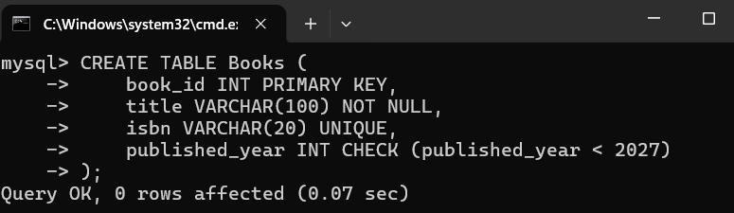
Step 3: Insert Records into Books Table
INSERT INTO Books (book_id, title, isbn, published_year) VALUES
(1, 'The Great Gatsby', '9780743273565', 1925),
(2, 'To Kill a Mockingbird', '9780061120084', 1960),
(3, '1984', '9780451524935', 1949);
Step 4: Display Books Table
SELECT * FROM Books;
Step 5: Create Members Table
CREATE TABLE Members (
member_id INT PRIMARY KEY,
full_name VARCHAR(100),
email VARCHAR(100) UNIQUE
);
CREATE TABLE Members (
member_id INT PRIMARY KEY,
full_name VARCHAR(100),
email VARCHAR(100) UNIQUE
);
Step 6: Insert Records into Members Table
INSERT INTO Members (member_id, full_name, email) VALUES
(101, 'John Smith', 'john.smith@email.com'),
(102, 'Emma Wilson', 'emma.wilson@email.com'),
(103, 'Michael Brown', 'michael.brown@email.com');
INSERT INTO Members (member_id, full_name, email) VALUES
(101, 'John Smith', 'john.smith@email.com'),
(102, 'Emma Wilson', 'emma.wilson@email.com'),
(103, 'Michael Brown', 'michael.brown@email.com');
SELECT * FROM Members;
Step 8: Create Loans Table
CREATE TABLE Loans (
loan_id INT PRIMARY KEY,
member_id INT,
book_id INT,
loan_date DATE,
FOREIGN KEY (member_id) REFERENCES Members(member_id),
FOREIGN KEY (book_id) REFERENCES Books(book_id)
);
Step 9: Insert Records into Loans Table
INSERT INTO Loans (loan_id, member_id, book_id, loan_date) VALUES
(1,101,1,'2025-01-05'),
(2,102,2,'2025-01-08'),
(3,103,3,'2025-01-10'),
(4,101,2,'2025-02-01'),
(5,102,1,'2025-02-05'),
(6,103,2,'2025-02-12'),
(7,101,3,'2025-03-01'),
(8,102,3,'2025-03-07'),
(9,103,1,'2025-03-15'),
(10,101,1,'2025-04-01');
Step 10: Display Loans Table
SELECT * FROM Loans;
Step 11: INNER JOIN Query
SELECT m.full_name AS Member_Name, b.title AS Book_Title
FROM Loans l
INNER JOIN Members m ON l.member_id = m.member_id
INNER JOIN Books b ON l.book_id = b.book_id;
Step 12: GROUP BY Query
SELECT published_year, COUNT(book_id) AS Total_Books
FROM Books
GROUP BY published_year
ORDER BY published_year;
Step 13: Create Donation_History Tab
CREATE TABLE Donation_History (
donation_id INT PRIMARY KEY,
book_id INT,
donor_name VARCHAR(100),
donation_date DATE,
FOREIGN KEY (book_id) REFERENCES Books(book_id)
);
Step 14: Start Transaction
START TRANSACTION;
Step 15: Insert New Book
INSERT INTO Books (book_id, title, isbn, published_year)
VALUES (4, 'Animal Farm', '9780451526342', 1945);
Step 16: Insert Donation Record
INSERT INTO Donation_History (donation_id, book_id, donor_name, donation_date)
VALUES (1, 4, 'Raj Kumar', CURDATE());
Step 17: Commit Transaction
COMMIT;
Step 18: Create Index
CREATE INDEX idx_books_isbn ON Books(isbn);
Step 19: Search Book Using ISBN
SELECT * FROM Books
WHERE isbn = '9780451524935';
